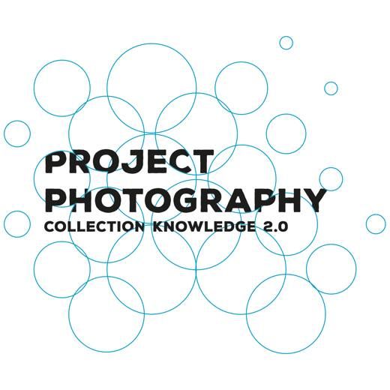
Launching of new project: Preservation of modern photographic works of art in museum collections.
Press Release
The Dutch Foundation for the Conservation of Contemporary Art (SBMK), sixteen museums, the University of Amsterdam (UvA) and the Cultural Heritage Agency of The Netherlands (RCE) will join forces in a large-scale collaborative project titled ‘Project Collection Knowledge 2.0 / Photography’. The goal of this three year project is to sustainably preserve photographic works of art in Dutch collections for the future, and as such, to make them accessible to the general public. Applied research will be used to develop a method whereby collection managers, conservators and others charged with collection care learn to identify and monitor their 20th and 21st Century photographic collection and if necessary, carry out preventative conservation measures. The project is a continuation of the successful pilot ‘Collection Knowledge 2.0/Pilot Plastics’ (2017-2019) that focused on the identification and conservation of various types of plastic, used in art and design objects. The project ‘Project Collection Knowledge 2.0 / Photography’ will run from October 1st 2020 until October 1st 2023 and is financially supported by the Gieskes-Strijbis Foundation, the Mondrian Fund, UvA, RCE and the Wertheimer Foundation, managed by the Prins Bernhard Culture Foundation.

It is impossible to imagine collections of modern and contemporary art without photographic works. Museums are increasingly in need of expertise to preserve both analogue and digital (colour) photographs. Expertise on printing processes, finishing techniques, photographic paper and supports as well as correct terminology is often lacking within Dutch museums. What are the best ways to store and exhibit photographs whilst preserving them for the future?

Identification ‘on the job’
In this collaborative project, lead by the SBMK and the UvA, partners will develop, share and implement practical knowledge to improve collection care, visibility and accessibility of photographic art works. Participating museum staff will learn ‘on the job’ about materials and techniques and how to identify photographic works in their own collection. During hands-on training surveying collections, research questions will be formulated and investigated, and in combination with existing national and international knowledge, a digital tool will be developed and tested that will help others world wide gain more insight into their modern photograph collections. As a result each of the 13 participating museum will have a sub-collection of surveyed, identified and well-registered photographic works. Key outcomes of the project will be the afore mentioned digital platform with information on the most common and/or problematic printing processes, finishing techniques, photographic papers and supports of both analogue and digital photography, as well as a physical set of reference material samples of many of the past and current photographic processes that are found in museum collections today.

Implementing the knowledge gained
During the project, under the guidance of the UvA and the Cultural Heritage Laboratory of RCE, two young professionals will be trained to specialize in the preservation of photography. Research will be carried out by students from the Master Conservation and Restoration of Cultural Heritage at the UvA. Lectures and seminars to disseminate knowledge learned will be organised for the public. The digital platform will be freely available, in both Dutch and English, to anyone interested in the preservation of photographs. The outcomes of this project will be applicable to collections worldwide. The project concludes with a public symposium during which the outcomes and results will be presented.

Partners
The ‘Project Photography’ is coordinated by the SBMK together with the UvA. Thirteen organisations having a modern photography collection are partners; Amsterdam Museum, Museum Boijmans Van Beuningen, Bonnefanten, De Domijnen, Frans Hals Museum| De Hallen, Het Nieuwe Instituut, Huis Marseille, Kröller-Müller Museum, Kunstmuseum Den Haag / Fotomuseum Den Haag, Stichting Nationaal Museum van Wereldculturen, Stedelijk Museum Amsterdam, Rabo Artcollection and RCE-Artcollections. Advisory partners are Rijksmuseum, NICAS, National Archives en Nederlands Fotomuseum.

About SBMK
The Dutch Foundation for the Conservation of Contemporary Art (SBMK) has, for 25 years, organised projects about collection care and conservation of contemporary art. Its aim is to develop good practice to benefit its stakeholders. Collaborations are carried out between collection managers, conservators, curators, scientists and researchers. Questions from the field on a range of problems (technical as well as ethical) are raised for discussion. For example, how do you deal with ephemeral materials or complex installation artworks? What role does the artist, the museum and the public have to play in the conservation of contemporary art? The SBMK initiates projects, ensures they are carried out and that the information is made available for peers in the field.

>> more about SBMK
>> more about the MA Conservation and Restoration of Cultural Heritage at the UvA
Contact: Paulien ’t Hoen (SBMK), 06 5358 6712 / info@sbmk.nl.

